**Website Planning Documentation**

**Home Page News Stories**

Main Story Title: **Chelsea’s Resurgence**

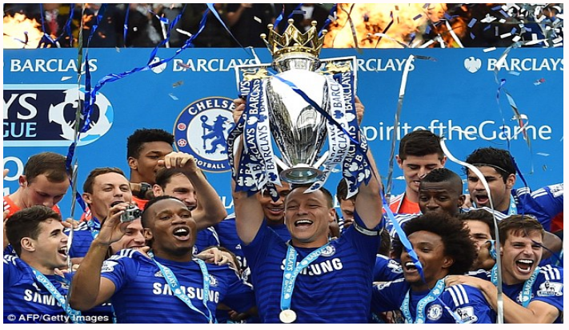

**Snippet of Article:**

After a terrible 2015/2016 campaign, Chelsea’s resurgence has come as a huge surprise to the rest of the division, taking the league by storm. Antonio Conte’s men have clearly turned fortunes around at Stamford as they currently sit proud on top of the league.

**View More:**

After a terrible 2015/2016 campaign, Chelsea’s resurgence has come as a huge surprise to the rest of the division, taking the league by storm. Antonio Conte’s men have clearly turned fortunes around at Stamford as they currently sit proud on top of the league.

The 2015/2016 season will arguably go down as the worst season in the club’s history due to the dramatic fall from grace. The season was filled with controversy due to off field antics, a lack discipline and poor behaviour from the club’s players and previous manager Jose Mourinho. Although Mourinho won the league in the 2014/2015 season with the club, he lost his dressing room by making a series of allegations and making outlandish claims regarding his players which started this capitulation. This led to the sacking of the beloved coach regarded as the “King of the Bridge”.

Antonio Conte took over from Mourinho in the summer of 2016. The move has proved to be successful as he has won over the dressing room and results on the pitch in this campaign have been outstanding. The change in formation (3:5:2) has been a major factor in his dominance. Chelsea now look unstoppable, unbeatable and at times unplayable. Will this form continue, or will another capitulation occur, only time will tell? As it stands the 2014/2015 champions are odds on favourites in clinching there 5th Premier league title.

News Story 1 title: **Ancelotti’s Dominant Bayern Hit 5**

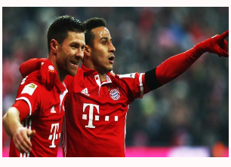

**Snippet of Article:**

Bayern strike 5 against a helpless Schalke side with Thiago Alcantara and Xabi Alonso amongst the goals.

**View More:**

Bayern hit 5 against a helpless Schalke side with Thiago Alcantara and Xabi Alonso amongst the goals.

A rampant Bayern Munich side increase their lead at the top of the Bundesliga. Ancelotti’s men played superbly, tearing Schalke apart at every opportunity. Robert Lewandowski Scored the first in the 15th Minute with a well-timed header from a Douglas Costa cross. Xabi Alonso Scored a screamer before the break with a superb 30-yard strike. Thiago added a third at the start of the second half tapping in from an Arjen Robben cross. Thomas Muller added a quick-fire double late on in the second half making 4:0 and then 5:0 respectively.

This win leaves Bayern at the helm of the Bundesliga at the midway point of the season. Can Bayern make it 9 out of 13 Bundesliga titles? As it stands it seems no team will catch them. They are certainly odds on favourites to win again.

Where does this leave Schalke? Schalke manager Markus Windier was very disappointed at his sides defeat. He said “Bayern played well and were the better side today, we were good in the first half, missed some chances but we made far too many mistakes which cost us the game”. Markus Windier needs a miracle to turn his sides fortunes around if they are to finish in a Europa League Position in the table.

News Story 2 title: **Barcelona Cruise to Victory in a Heated Catalan Derby**

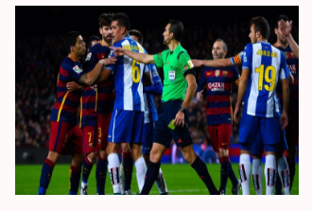

**Snippet of Article:**

Barcelona hit 4 against a heated Espanyol side with Lionel Messi and Luis Suarez scoring a double either side of half time.

**View More:**

Barcelona hit 4 against a heated Espanyol side with Lionel Messi and Luis Suarez scoring a double either side of half time.

David Lopez fired in a consolation in a rampant Barcelona Victory as they look to put pressure on the league leaders and title rivals. Enrique’s men played Brilliantly, as Suarez, Neymar and Messi put on a masterclass for the home crowds. David Lopez devastated the Camp Nou scoring the first in the 7th Minute as he went around Barcelona Keeper Ter Stegen. A quick-fire Messi double put the favourites back in the lead with Luis Suarez adding a double in the second half making it 4:1 from two Neymar crosses. The match finished in controversy as Messi had a heated exchange with Espanyol player Jurado.

This Result leaves Barcelona in contention to win the La Liga title. Can Barcelona win another La Liga title? As it stands it is a three-horse race to the title with Real Madrid the favourites.

Where does this leave Espanyol? Espanyol remain on target as they sit nicely in mid table with a possible Europa League Position up for grabs. Espanyol will need to improve their conduct on the pitch and remain focussed if they are to achieve their goals for the rest of the campaign. They will need to put this defeat and controversy to bed and concentrate on their next fixture.

News Story 3 title: **Schneiderlin Exit Imminent**

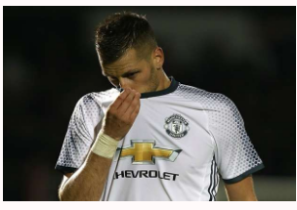

**Snippet of Article:**

Morgan Schneiderlin’s Manchester United nightmare looks set to be over as Everton agree a fee to sign the defensive midfielder.

**View More:**

Morgan Schneiderlin’s Manchester United nightmare looks set to be over as Everton agree a fee to sign the defensive midfielder. The move is set to be completed subject to a medical with personal terms already agreed.

With Memphis Depay joining Lyon, Manchester United seem to have gained sizeable fees for the pair in the process. The transfer fee for Schneiderlin is reported to be £21 million pounds on a four-year deal. Schneiderlin states “I am excited about the prospect of joining a big club like Everton and I hope to help the team win trophies in the future.”

Morgan Schneiderlin will wear the number “2” Jersey at Everton, with the player set for a medical tomorrow afternoon.

News Story 4 title: **Messi Overhead Screamer**

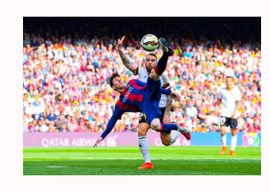

**Snippet of Article:**

Lionel Messi scores late screamer in this mid-week La Liga fixture against Valencia. A helpless Nicolas Otamendi looks on as Messi is in full motion in scoring this sublime goal.

**View More:**

Lionel Messi scores late screamer in this mid-week La Liga fixture against Valencia. A helpless Nicolas Otamendi looks on as Messi is in full motion in scoring this sublime goal. This victory may prove to be vital in the title race as Barcelona look to put pressure on League Leaders Real Madrid and fellow title challengers Sevilla.

Messi on scoring this superb goal stated “I am happy to score a big goal like this, the most important is the team, we played well and we hope this continues”.

Barcelona are going from strength to strength as Luis Enrique’s side are playing some sublime football. Valencia played well throughout the match and would deem themselves as unlucky not get a point but for a sublime 88th minute overhead kick from one of the best players in history let alone the world.

**La Liga News Stories**

Main Story Title: **Can Barcelona make it Back to Back La Liga titles?**

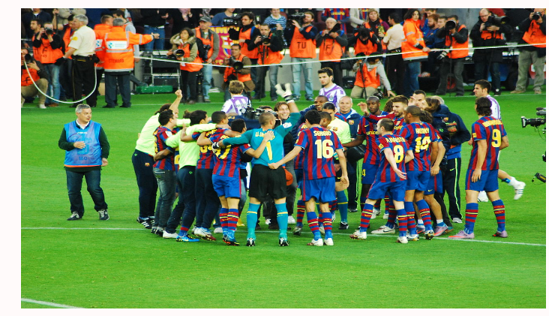

**Snippet of Article:**

After a superb 2015/2016 campaign. Can Barcelona successfully defend their La Liga title?

**View More:**

After a superb 2015/2016 campaign, Can Barcelona successfully defend their La Liga title?

Barcelona’s form has come as no surprise to the rest of the division, yet again, they are taking the rest of the league by storm. Luis Enrique’s men are clearly continuing their superb form from last season and look like the favourites to regain their crown.

The 2015/2016 season will arguably go down as one of the best footballing seasons in the club’s history due to the attacking prowess of Messi, Suarez and Neymar. The season was filled with great team performances which led to them being crowned as La Liga champions

Although Barcelona are playing brilliantly this campaign, competition is fierce, with Real Madrid currently being the league leaders and Sevilla closely challenging. If Barcelona were to retain their title, it would be a remarkable achievement.

New Story 1 Title: **Ronaldo Sustains Ankle Injury**

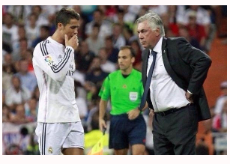

**Snippet of Article:**

Cristiano Ronaldo is set to miss three weeks of playing time as he has sustained a heavy knock in training on his right ankle. The injury sustained was caused by a heavy challenge from team mate Marcelo.

**View More:**

Cristiano Ronaldo is set to miss three weeks of playing time as he has sustained a heavy knock in training on his right ankle. The injury sustained was caused by a heavy challenge from team mate Marcelo. The injury sustained will rule out Ronaldo from playing in the next three upcoming La Liga fixtures.

Real Madrid manager Zinedine Zidane stated “The injury is not as serious as we worse feared, we thought it would be ligament damage however it is just a swollen ankle with bad bruising. Cristiano will be back three weeks hopefully but we will not rush his recovery”

The injury to Ronaldo means he will some Key La Liga fixtures which could prove costly to Real Madrid’s title challenge. Can Real Madrid continue their fine form without their star player. Only time will tell.

New Story 2 Title: **Sanchez Storms Out of Press Conference**

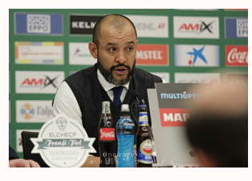

**Snippet of Article:**

An angry Victor Sanchez stormed out of today’s La Liga press conference as he attacks the press for putting his position under scrutiny.

**View More:**

An angry Victor Sanchez stormed out of today’s La Liga press conference as he attacks the press for putting his position under scrutiny. The Real Betis manager is under pressure and is currently odds on favourite to lose his job due to a fall out with the fans.

The boos from the crowd cannot be overlooked, although Sanchez would state otherwise “I do not care, I did not here these cheers from the crowd, I care only about victories and results. How dare you ask me this question, consider the press conference over”. Will Victor Sanchez be manager of Real Bet? The club is set to make statement which will come within the next few days in regards to their manager’s outburst.

New Story 3 Title: **Kameni Sees Red**

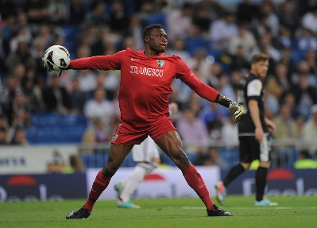

**Snippet of Article:**

Malaga goalkeeper Carlos Kameni gets sent off in heated clash as he fouls Antoine Griezmann inside the 6-yard Box.

**View More:**

Malaga goalkeeper Carlos Kameni gets sent off in heated clash as he fouls Antoine Griezmann inside the 6-yard Box. Antoine Griezmann looked set to score as he rounded the Cameroon International goalkeeper with ease only for then to be fouled. As a result, Kameni got shown a straight red card and got ushered towards the tunnel. Griezmann stepped up to take the resulting penalty making it 1:0 and giving Athletico Madrid the well-deserved victory they required.

Carlos Kameni is set to miss the next two games through suspension with Aarón Escandell set deputise in Kameni’s absence.

New Story 4 Title: **Brilliant Busquets**

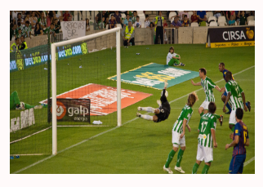

**Snippet of Article:**

**How important is Busquets sensational form to Barcelona’s title challenge?**

**View More:**

How important is Busquets sensational form to Barcelona’s title challenge?

Sergio Busquets is very much the unsung hero in a Barcelona team dominated by superstars. Although he may not get the headline accolades, goals or assists. His Phenomenal form is detrimental in Barcelona’s pursuit for a consecutive La Liga Title.

Sergio Busquets is the water carrier if you may say so, much like Chelsea’s N’Golo Kanté. His responsibility is to break up possession and pass the ball to the more elegant players in the team. As it stands Sergio Busquets is a very important player for Barcelona. He may not have the same ability on the ball as Iniesta or Rakitic but he is vital for this Barcelona team as the attacks begin when he wins the ball back.

**Bundesliga News Stories**

Main Story Title: **Amazing Allianz Arena**

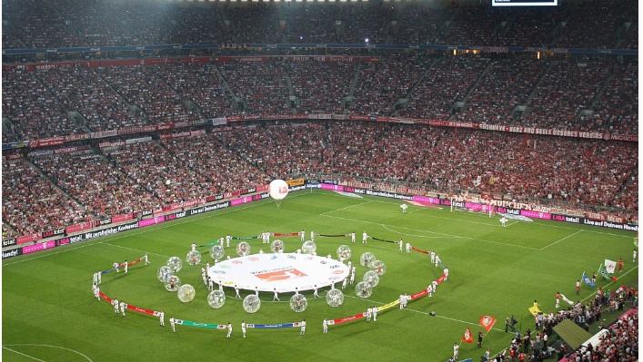

**Snippet of Article:**

Home to arguably one of the best teams on teams in the world. Bayern Munich's 75,000-capacity stadium is widely known for its exterior of inflated ETFE plastic panels. It is the first stadium in the world with a full colour changing exterior.

**View More:**

Home to arguably one of the best teams on teams in the world. Bayern Munich's 75,000-capacity stadium is widely known for its exterior of inflated ETFE plastic panels. It is the first stadium in the world with a full colour changing exterior.

The Allianz Arena stadium officially opened in 2005 and is now regarded as one of the most modern and amazing football stadiums in the world. Bayern Munich's home is truly a remarkable one.

News Story 1 title: **Alonso Like "Fine Wine"**

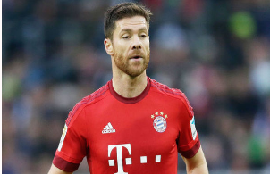

**Snippet of Article:**

Xabi Alonso is arguably in the form of his life at the Bavarians at the ripe old age of 35. The player is in the twilight years of his career and like "Fine Wine" seems to only get better.

**View More**

Xabi Alonso is arguably in the form of his life at the Bavarians at the ripe old age of 35. The player is in the twilight years of his career and like "Fine Wine" seems to only get better.

When Toni Kroos left Bayern in the summer, eyebrows were raised at his replacement. Xabi Alonso was bought in on a two-year contract and has been brilliant since joining the current Bundesliga champions. Now in to his second season the World Cup winner talks about the secrets behind his immense form.

Xabi Alonso states "There is no secret to my form, I just want to play well, do my best for my team mates and win trophies". Asked whether he has considered hanging up his boots he states "I am not thinking about that just yet, I want to play at the highest level for as long as possible".

Alonso has been superb for many years, he is without doubt regarded as one of the best midfielders of his generation and so he should be. He has won trophies wherever he has been. His incredible passing range is second to none and at this rate long may his dazzling form continue.

News Story 2 title: **Red Bull Leipzig Take Bundesliga By Storm**

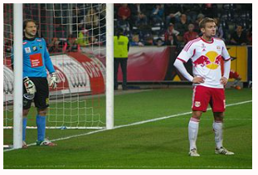

**Snippet of Article:**

Currently sitting comfortably in second place, Red Bull Leipzig are playing some tremendous football in the process.

**View More:**

Currently sitting comfortably in second place, Red Bull Leipzig are playing some tremendous football in the process. The Red Bull outfit are currently undefeated in 9 games. Can they beat Bayern to the Bundesliga crown?

On paper Bayern have the far superior squad and can buy any player in world football if they choose to do so. Red Bull Leipzig are relatively new to the Bundesliga, newly promoted, the sides dominance has come as a major surprise to the rest of the division. They are currently sitting on an automatic champions league qualification place. Looking like Bayern’s closest challengers, can Red Bull Leipzig pull of the impossible and knock Bayern of top spot? We shall find out as the season unfolds.

News Story 3 title: **Hernandez Strikes twice to give Leverkusen Victory**

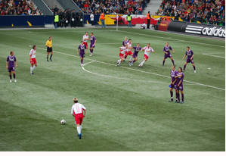

**Snippet of Article:**

Javier Hernandez strikes twice in the first half as Bayer Leverkusen Pick Up Comfortable Win.

**View More:**

Javier Hernandez strikes twice in the first half as Bayer Leverkusen Pick Up Comfortable Win.

Bayer Leverkusen are back to winning ways as they win comfortably. Bayer had not won a game in their previous 3 league fixtures. The slump in form came due to Leverkusen’s participation in the champions league. The players level has dropped drastically in recent weeks and Leverkusen Manager Roger Schmidt was delighted about his team’s performance. Schmidt stated “The victory against Hamburg was crucial. I am happy with result and performance as we are back to winning ways.

Hernandez’s two goals takes his tally to 6 Bundesliga Goals for the season and provides a crucial victory for Leverkusen.

News Story 4 title: **Eintracht Frankfurt Defeat Schalke**

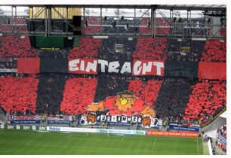

**Snippet of Article:**

Eintracht Frankfurt Defeat Schalke in a less than intriguing encounter. The match ended 1:0.

**View More:**

Eintracht Frankfurt Defeat Schalke in a less than intriguing encounter. The match ended 1:0. There was not much to cheer for either sides supporters as the match almost ended in stalemate. Both sides lacked intent as chances were few and far between.

The deadlock came in the 88th minute as Alexander Meier broke through on goal and finished past an on-rushing Ralf Fährmann. Neither side deserved to lose this encounter as they were both equally as poor.

The result may prove to be beneficial to Frankfurt’s season as it may kick start their campaign.

**Serie A News Stories**

Main Story Title: **Palermo Woes Deepen as Fans Throw Flares**

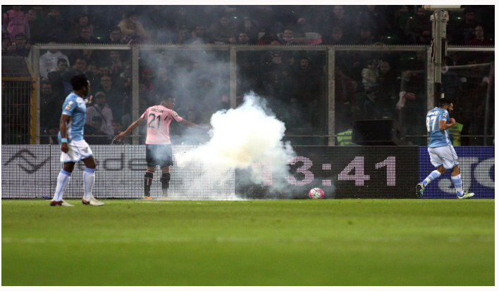

**Snippet of Article:**

Palermo's Serie A relegation woes deepened in a trouble-hit 3-0 defeat to Lazio that saw the match stopped twice by the referee as rocket flares came dangerously close to hitting players.

**View More:**

Palermo's Serie A relegation woes deepened in a trouble-hit 3-0 defeat to Lazio that saw the match stopped twice by the referee as rocket flares came dangerously close to hitting players.

German veteran Miroslav Klose claimed his 50th and 51st Serie A goals and Felipe Anderson added the finishing touch. Lazio midfielder Antonio Candreva quickly covered his ears in panic after narrowly escaping an exploding flare as angry Palermo fans vented their frustration amid fears of relegation.

Lazio goal scorer Miroslav Klose stated "This shouldn't be happening in football... but you can perhaps understand their anger because they obviously don't want to be relegated to Serie B."

News Story 1 title: **Roma Falter Against Sampdoria**

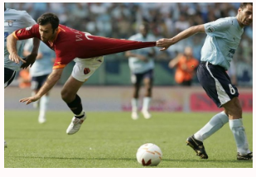

**Snippet of Article:**

Roma surrendered their feint Serie A title via conceding two poor goals within seven minutes of taking a 2-1 lead at Sampdoria. The loss was Roma's first defeat of 2017 and has pegged them back in the title race.

**View More:**

Roma surrendered their feint Serie A title via conceding two poor goals within seven minutes of taking a 2-1 lead at Sampdoria. The loss was Roma's first defeat of 2017 and has pegged them back in the title race.

Edin Dzeko's well taken 15th league goal of the season -- his first away from home since late October -- looked to have put the Giallorossi over the top after dominating the early stages of the second half, but uncharacteristically slapstick defending allowed Sampdoria to quickly reverse the proceedings.

First, Patrik Schick took down and rolled home Luis Muriel's bog-standard flick-on with 19 minutes left, and almost immediately afterwards Muriel's free kick pinged off Radja Nainggolan to beat an unfortunate Wojciech Szczesny, who had previously saved Roma's skin with superb keeping on at least three occasions.

Teams that throw away leads twice in 90 minutes don't win league titles, so that looks to be that for another year. As it stands Roma cannot afford anymore slip ups.

News Story 2 title: **Lazio’s European Hopes**

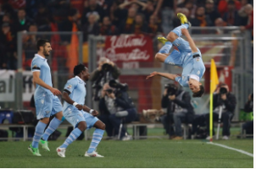

**Snippet of Article:**

Lazio currently sit in third place in Serie A and look set to be in pole position for the elite European places. What are their chances of staying there?

**View More:**

Lazio currently sit in third place in Serie A and look set to be in pole position for the elite European places. What are their chances of staying there?

Lazio will be hoping for a champions league position; some fine displays currently see them sat in third place. The question is can they remain there? Currently Lazio are one of the inform teams in the league with one of the best young squads in the division.

The form of Felipe Anderson has been pivotal for their campaign so far and if he remains at the club then they will have huge chance in achieving a third-place finish. They could even possibly challenge Juventus for the title.

News Story 3 title: **Juventus League Leaders**



**Snippet of Article:**

Massimiliano Allegri's men recovered from their recent defeat to Fiorentina to ensure they stay well ahead of Roma and Napoli with a game to spare.

**View More:**

Massimiliano Allegri's men recovered from their recent defeat to Fiorentina to ensure they stay well ahead of Roma and Napoli with a game to spare.

Juventus look set to win another consecutive Serie A title as they sit firmly at the top of the table.

The recent victory against close rivals Lazio just showed how far ahead Juventus are in comparison to their league rivals. Goals from Dybala and Higuaín either side of half time sealed the victory.

Juve controlled proceedings and extended their home league winning streak to an astonishing 27 matches after victory in Allegri's 300th Serie A match as a head coach.

News Story 4 title: **Can Juve Retain Their Crown?**

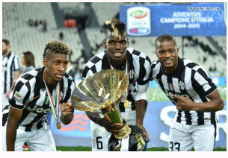

**Snippet of Article:**

After a superb 2015/2016 campaign. Can Juventus successfully defend their Serie A title?

**View More:**

After a superb 2015/2016 campaign. Can Juventus successfully defend their Serie A title?

Juventus’s form has come as no surprise to the rest of the division, yet again, they are taking the rest of the league by storm. Massimiliano Allegri’s men are clearly continuing their superb form from last season and look like the favourites to regain their crown.

Despite the loss of Pogba, Juventus seem to be playing brilliantly. The Frenchman was instrumental last campaign however it looks like he is now the forgotten man and is a thing of the past as the team continues their fine form.

Although Juventus are playing brilliantly this campaign, competition is fierce, with Roma currently being in form along with Lazio sniffing around. If Juventus were to retain their title, it would be a remarkable achievement as they would be doing so without there talisman.

**Premier League News Stories**

**Main Story Title:** The Rise and Fall of the Foxes

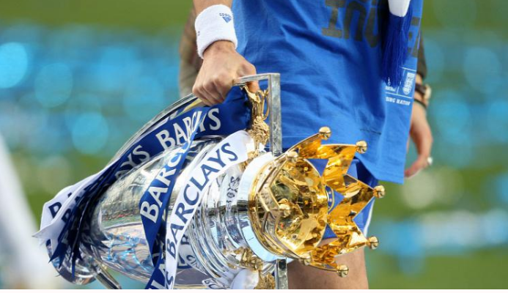

**Snippet of Article:**

Leicester City celebrated their coronation as Premier League champions last season. This was the first title in their 132-year history with victory over Everton on a day of elation at the King Power Stadium.

**View More:**

Leicester City celebrated their coronation as Premier League champions last season. This was the first title in their 132-year history with victory over Everton on a day of elation at the King Power Stadium

Leicester’s tale captured the world's imagination when captain Wes Morgan and manager Claudio Ranieri jointly lifted the Premier League trophy as they completed the journey from relegation battlers and 5,000-1 outsiders to champions in the space of 12 months.

This season however has been a calamity as Leicester currently sit near the relegation places. It could be argued that European football has affected their performances in the premier league. The loss of N’Golo Kanté has been a major factor as they lost the dynamic midfielder to Chelsea in the summer. The chance of Leicester retaining their crown is far gone as Chelsea currently sit top of the league in what is shaping up to be a four-horse title race. As it stands Chelsea are odds on favourites to be crowned champions for a 5th time.

News Story 1 title: **Giroud’s Scintillating Form**

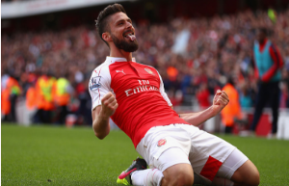

**Snippet of Article:**

Olivier Giroud’s goal scoring form is back on the rise as he is determined to fire Arsenal to their first premiership crown in 12 years. Giroud states "The Premier League is my main target so after when I will win it one day, why not, you never know."

**View More:**

Olivier Giroud’s goal scoring form is back on the rise as he is determined to fire Arsenal to their first premiership crown in 12 years. Giroud states "The Premier League is my main target so after when I will win it one day, why not, you never know."

Giroud is in fine form right now, scoring in his last nine starts for Arsenal in all competitions.

While the 30-year-old said, he enjoyed the competition for starting places, he holds an expectation that his goal-scoring form will contribute to a much more consistent place in Arsene Wenger's starting line-up.

Giroud also stated "It's always nice to have a good competition between us and if I keep scoring, why not stay in the starting eleven?" If Giroud’s fine form continues throughout the campaign, he may fire Arsenal to their first premier league title in 12 years

News Story 2 title: **Coutinho Suffers Knee Injury**

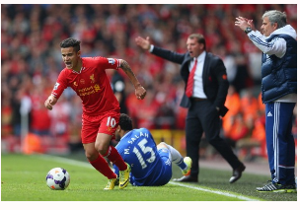

**Snippet of Article:**

Phillipe Coutinho is set to miss four weeks of playing time as he has sustained a heavy knock in training on his left knee. The injury sustained was caused by a heavy challenge from team mate Alberto Moreno.

**View More:**

Phillipe Coutinho is set to miss four weeks of playing time as he has sustained a heavy knock in training on his left knee. The injury sustained was caused by a heavy challenge from team mate Alberto Moreno.

Liverpool manager Jürgen Klopp stated “The injury is bad, it is serious, it is just as bad as we thought, it is ligament damage however. Phil will be back in four weeks hopefully but we will not rush his recovery”

The injury to Coutinho means he will miss some Key premier league fixtures which could prove costly to Liverpool’s title challenge. Can Liverpool continue their fine form without their star player? Only time will tell.

News Story 3 title: **Chelsea Flying**

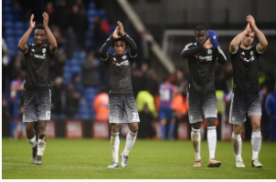

**Snippet of Article:**

Chelsea are flying in the league at the moment, Conte’s switch to the 3-5-2 system has proved to be dividend as they beat Hull City by 2 goals to 0.

**View More:**

Chelsea are flying in the league at the moment, Conte’s switch to the 3-5-2 system has proved to be dividend as they beat Hull City by 2 goals to 0.

The change in formation (3:5:2) has been a major factor in his dominance. Chelsea now look unstoppable, unbeatable and at times unplayable. Chelsea scored two goals at the start of the second half through Diego Costa.

As it stands Chelsea’s formidable form will continue and they are odds on favourites to clinching there 5th Premier league title.

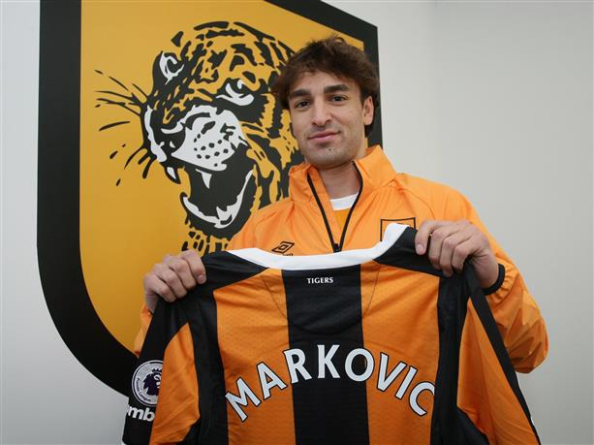News Story 4 title: **Markovic Joins Hull from Liverpool On Loan**

**Snippet of Article:**

Lazar Markovic has joined Premier League strugglers Hull City on loan until the end of the season. The Serbian midfielder has struggled for playing time at Anfield and has failed at previous loan spells.

**View More:**

Lazar Markovic has joined Premier League strugglers Hull City on loan until the end of the season. The Serbian midfielder has struggled for playing time at Anfield and has failed at previous loan spells.

For the first half of the season Markovic spent time on loan at Sporting Lisbon, after only playing twice, Liverpool recalled the midfielder and Hull City came in a with a loan proposal, which will include a buy clause at the end of the system.

For Markovic this is quite possibly the quick he starts he needs for the development his career. Once regarded as one of Europe’s brightest young talents, Hull City may just be the perfect pace for Markovic to kick start his career.

**History of League Leaders Info**

**Chelsea**

Chelsea Football Club is an English professional football club based in Fulham, London, that competes in the Premier League. Founded in 1905, the club's home ground Stamford Bridge. Chelsea are the current league leaders of the Barclays Premier League and are on course to win their 6th league trophy

Chelsea had their first major success in 1955, when they won the league championship. They then won various cup competitions between 1965 and 1996. The club's greatest period of success has come during the last two decades; winning 21 trophies since 1997. Chelsea have won five national league titles, seven FA Cups, five League Cups and four FA Community Shields, one UEFA Champions League, two UEFA Cup Winners' Cups, one UEFA Europa League and one UEFA Super Cup.

**Real Madrid**

Real Madrid is a professional football club based in Madrid, Spain founded in 1902. The team has traditionally worn a white home kit since inception. The team has played its home matches in the 85,454-capacity Santiago Bernabéu Stadium in downtown Madrid since 1947. Unlike most European sporting entities. Real Madrid are the current league leaders of La Liga and are on course to win their 33rd La Liga title.

The club is one of the most widely supported teams in the world. In domestic football, the club has won a record 32 La Liga titles, 19 Copa del Rey, nine Supercopa de España, a Copa Eva Duarte, and a Copa de la Liga. In international football, the club has won a record 11 European Cup/UEFA Champions League titles, a joint record three Intercontinental Cups, two UEFA Cups, three UEFA Super Cups and two FIFA Club World Cups. In terms of international titles won, Real Madrid is the most successful club in the world.

**Juventus**

Juventus Football Club is a professional Italian association football club based in Turin, Piedmont. Founded in 1897 as Sport-Club Juventus by a group of young Torinese students. Juventus was the first professional club in the country Italy. The club's fan base is larger than any other Italian football club and is one of the largest worldwide. Juventus are the current league leaders of Serie A and are on course to win their 33rd Serie A title.

Juventus is the most successful club in Italian football and one of the most awarded globally. Overall, they have won sixty-one official titles on the national and international stage, more than any other Italian club: a record thirty-two official league titles, a record eleven Coppa Italia titles, a record seven Supercoppa Italiana titles, and, with eleven titles in confederation and inter-confederation competitions (two Intercontinental Cups, two European Champion Clubs' Cup/UEFA Champions Leagues, one European Cup Winners' Cup, three UEFA Cups, two UEFA Super Cups and one UEFA Intertoto Cup).

**Bayern Munich**

Bayern Munich, or FC Bayern, is a German sports club based in Munich, Bavaria, Germany. It is best known for its professional football team, which plays in the Bundesliga, the top tier of the German football league system. The team colours are red and white, and the team crest shows the white and blue flag of Bavaria. Bayern Munich is the most successful club in German football history, having won a record 26 national titles and 18 national cups. FC Bayern are the current league leaders of the Bundesliga and are on course to win their 27th Bundesliga title.

FC Bayern was founded in 1900 by 11 football players, led by Franz John. Overall, Bayern has reached ten European Cup/UEFA Champions League finals, most recently winning their fifth title in 2013 as part of a continental treble. Bayern has also won one UEFA Cup, one European Cup Winners' Cup, one UEFA Super Cup, one FIFA Club World Cup and two Intercontinental Cups, making it one of the most successful European clubs internationally. Since the formation of the Bundesliga, Bayern has been the dominant club in German football with 26 titles and has won 8 of the last 12 titles.